**DAILY ONLINE ACTIVITIES SUMMARY**

|  |  |  |  |  |  |  |  |  |
| --- | --- | --- | --- | --- | --- | --- | --- | --- |
| **Date:** | **16-07-2020** | | | | | **Name:** | **Anix Jugal D’Cunha** | |
| **Sem & Sec** | **8 sem , A sec** | | | | | **USN:** | **4AL16CS013** | |
| **Online Test Summary** | | | | | | | | |
| **Subject** | | **Not Conducted** | | | | | | |
| **Max. Marks** | | **--** | | **Score** | | | **--** | |
| **Certification Course Summary** | | | | | | | | |
| **Course** | **Complete PHP OOP Concepts for Absolute Beginners + Projects** | | | | | | | |
| **Certificate Provider** | | | **Udemy** | | **Duration** | | | 10.5 hours |
| **Coding Challenges** | | | | | | | | |
| **Problem Statement:** C Program To Count Total Number Of Notes in Given Amount. | | | | | | | | |
| **Status: Competed** | | | | | | | | |
| **Uploaded the report in Github** | | | | | **yes** | | | |
| **If yes Repository name** | | | | | **alvas-education-foundation/dcunhaanixjugal** | | | |
| **Uploaded the report in slack** | | | | | **yes** | | | |

Online Test Details: (Attach the snapshot and briefly write the report for the same)

**Not Conducted**

Certification Course Details: (Attach the snapshot and briefly write the report for the same)

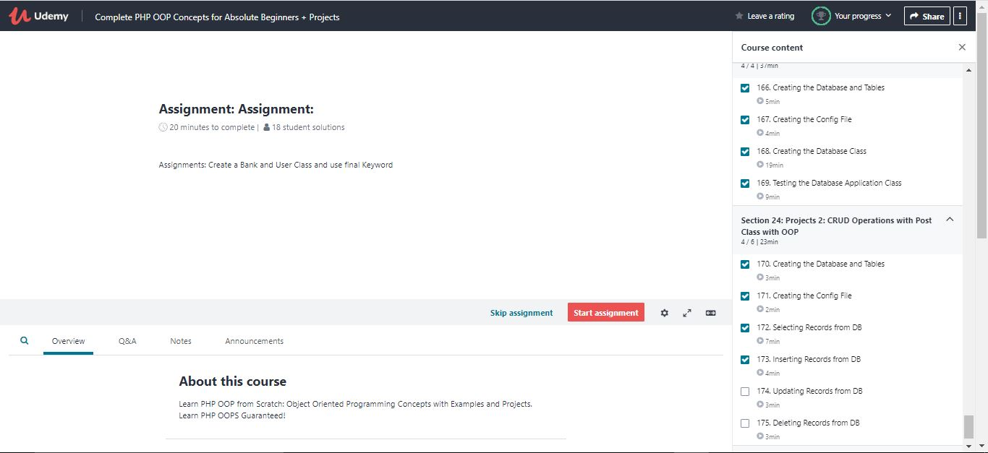

Coding Challenges Details: (Attach the snapshot and briefly write the report for the same)

## Program-> C Program To Count Total Number Of Notes in Given Amount.

|  |
| --- |
|  |

**int main() {**

**int a[8]={500,100,50,20,10,5,2,1},m,temp,i;**

**printf("Enter the amount:");**

**scanf("%d",&m);**

**temp=m;**

**for(i=0;i<8;i++) {**

**printf("\n%d notes is:%d",a[i],temp/a[i]);**

**temp=temp%a[i];**

**}**

**}**

**Output**

**Enter the amount:3456**

**500 notes is:6**

**100 notes is:4**

**50 notes is:1**

**20 notes is:0**

**10 notes is:0**

**5 notes is:1**

**2 notes is:0**

**1 notes is:1**

**Press any**